**Russian Real Estate Valuation: Project 1**

**MSDS 6371 Applied Statistics - Modeling and Inference**

**Dr. Anthony Tanaydin - Fall 2018**

**Allen Crane**

**Brock Friedrich**

**Matthew Trevathan**

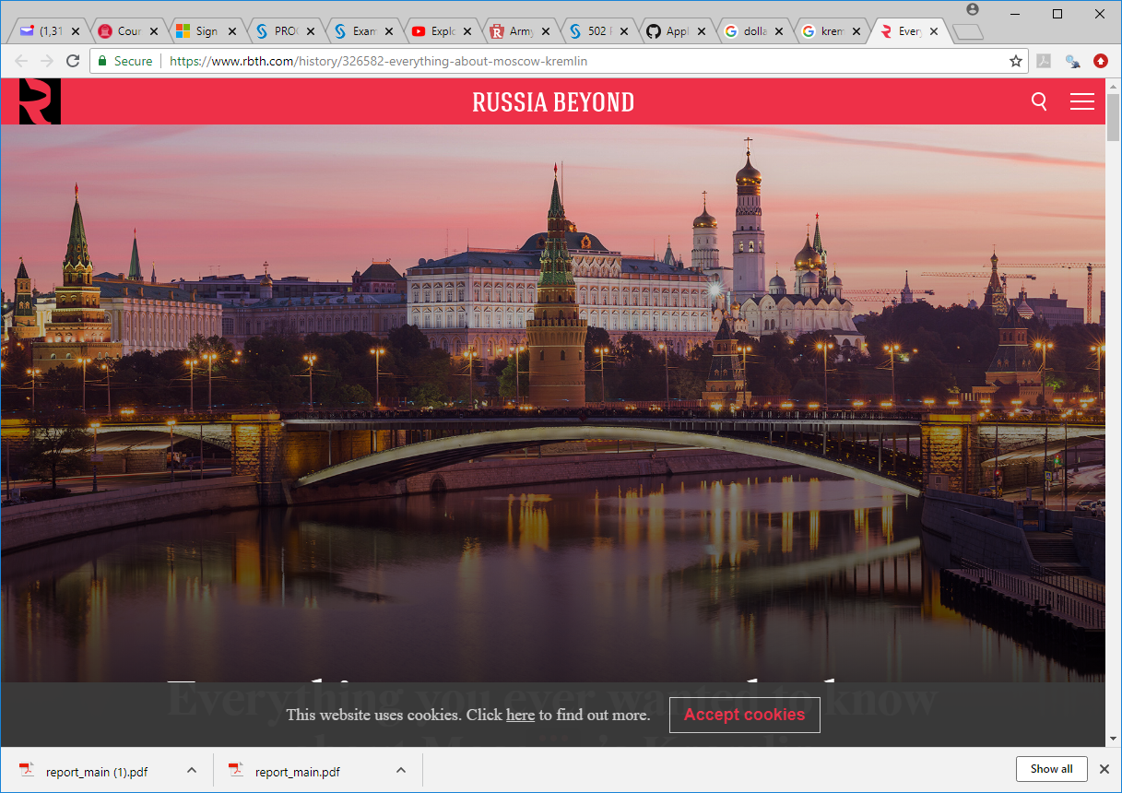



**Introduction:**

For our project, we have been asked to assist the Russian bank Sberbank to predict real estate prices with more certainty, so they can provide more certainty to their customers and value to their shareholders.The goal of this analysis is to build 2 models for the prediction of Russian real estate property. One model will predict the individual property price given some or all of the variables, and another model to predict the mean price of the properties. Both models will use the TRAIN data set to build the model and the PREDICTION data set for the test model.

**Description of the data with a table or a reference to a table**

The TRAIN data set was used for this modeling effort. The original file consists of 30,471 observations with 292 variables each. Appendix A contains the complete data dictionary and explanation of variables.

**Data Cleaning / Wrangling**

**(any renaming of variables or standardizing of values)**

**A.** The following variable names exceeded 32 characters, and therefore needed to be trimmed to shorter variable names:

**Before After .**

preschool_education_centers_raion ps_educ_centers_raion

school_education_centers_top_20_raion s_educ_centers_top20_raion

raion_build_count_with_material_info raion_bld_cnt_material_info

public_transport_station_min_walk pub_trans_stn_min_walk

**B.** Some variables exhibited significant curvature in the QQ plot, so the following variables were created using a log transformation on the original data:

**Before After .**

area_m log_area_m = log(area_m)

price_doc log_price_doc=log(price_doc)

**C.** In SAS, variables cannot begin with numeric values. As a result, for those of us coding in SAS, we needed rename the variables to begin with non-numeric values. Using “group_” to proceed the variable names, we have the following:

**Before After .**

0_6_all group_0_6_all

0_6_male group_0_6_male

0_6_female group_0_6_female

7_14_all group_7_14_all

7_14_male group_7_14_male

7_14_female group_7_14_female

0_17_all group_0_17_all

0_17_male group_0_17_male

0_17_female group_0_17_female

16_29_all group_16_29_all

16_29_male group_16_29_male

16_29_female group_16_29_female

0_13_all group_0_13_all

0_13_male group_0_13_male

0_13_female group_0_13_female

**D.** In SAS, variables cannot contain dashes/hyphens (“-”). As a result, for those of us coding in SAS, we needed rename the variables not include dashes/hyphens (“-”). Using an underscore (“_”) to replace (“-”), we have the following:

**Before After .**

build_count_1921-1945 build_count_1921_1945

'build_count_1946-1970 build_count_1946_1970

'build_count_1971-1995 build_count_1971_1995

**E.** Several numeric variables--assumed to be candidates for regression analysis--contained “NA” values. This caused them to be considered by SAS as character variables when the data was loaded into a SAS data set. There is probably a way to do the following in one step, but three steps were used to do this data processing step:

**1) The first step was to convert the “NA” values to missing (“”):**

**Before After .**

build_year="NA" then build_year=""

cafe_avg_price_500="NA" then cafe_avg_price_500=""

cafe_avg_price_1000="NA" then cafe_avg_price_1000=""

cafe_sum_1000_max_price_avg="NA" then cafe_sum_1000_max_price_avg=""

cafe_sum_1000_min_price_avg="NA" then cafe_sum_1000_min_price_avg=""

cafe_sum_500_max_price_avg="NA" then cafe_sum_500_max_price_avg=""

cafe_sum_500_min_price_avg="NA" then cafe_sum_500_min_price_avg=""

hospital_beds_raion="NA" then hospital_beds_raion=""

kitch_sq="NA" then kitch_sq=""

material="NA" then material=""

max_floor="NA" then max_floor=""

num_room="NA" then num_room=""

state="NA" then state=""

preschool_quota="NA" then preschool_quota=""

life_sq="NA" then life_sq=""

floor="NA" then floor=""

school_quota="NA" then school_quota=""

raion_bld_cnt_material_info="NA" then raion_bld_cnt_material_info=""

build_count_block="NA" then build_count_block=""

build_count_wood="NA" then build_count_wood=""

build_count_frame="NA" then build_count_frame=""

build_count_brick="NA" then build_count_brick=""

build_count_monolith="NA" then build_count_monolith=""

build_count_panel="NA" then build_count_panel=""

build_count_foam="NA" then build_count_foam=""

build_count_slag="NA" then build_count_slag=""

build_count_mix="NA" then build_count_mix=""

raion_build_count_with_builddate="NA" then raion_build_count_with_builddate=""

build_count_before_1920="NA" then build_count_before_1920=""

build_count_1921_1945="NA" then build_count_1921_1945=""

build_count_1946_1970="NA" then build_count_1946_1970=""

build_count_1971_1995="NA" then build_count_1971_1995=""

build_count_after_1995="NA" then build_count_after_1995=""

metro_min_walk="NA" then metro_min_walk=""

metro_km_walk="NA" then metro_km_walk=""

railroad_station_walk_km="NA" then railroad_station_walk_km=""

railroad_station_walk_min="NA" then railroad_station_walk_min=""

ID_railroad_station_walk="NA" then ID_railroad_station_walk=""

cafe_sum_1500_min_price_avg="NA" then cafe_sum_1500_min_price_avg=""

cafe_sum_1500_max_price_avg="NA" then cafe_sum_1500_max_price_avg=""

cafe_avg_price_1500="NA" then cafe_avg_price_1500=""

cafe_sum_2000_min_price_avg="NA" then cafe_sum_2000_min_price_avg=""

cafe_sum_2000_max_price_avg="NA" then cafe_sum_2000_max_price_avg=""

cafe_avg_price_2000="NA" then cafe_avg_price_2000=""

cafe_sum_3000_min_price_avg="NA" then cafe_sum_3000_min_price_avg=""

cafe_sum_3000_max_price_avg="NA" then cafe_sum_3000_max_price_avg=""

cafe_avg_price_3000="NA" then cafe_avg_price_3000=""

cafe_sum_5000_min_price_avg="NA" then cafe_sum_5000_min_price_avg=""

cafe_sum_5000_max_price_avg="NA" then cafe_sum_5000_max_price_avg=""

cafe_avg_price_5000="NA" then cafe_avg_price_5000=""

prom_part_5000="NA" then prom_part_5000=""

**2) The second step was to convert the missing variables (“”) to numeric:**

**Before After .**

build_year = '' n_build_year = input(build_year, 8.)

cafe_avg_price_500 = '' n_cafe_avg_price_500 = input(cafe_avg_price_500, 8.)

cafe_avg_price_1000 = '' n_cafe_avg_price_1000 = input(cafe_avg_price_1000, 8.)

cafe_sum_1000_max_price_avg = '' n_cafe_sum_1000_max_price_avg = input(cafe_sum_1000_max_price_avg, 8.)

cafe_sum_1000_min_price_avg = '' _cafe_sum_1000_min_price_avg = input(cafe_sum_1000_min_price_avg, 8.)

cafe_sum_500_max_price_avg = '' _cafe_sum_500_max_price_avg = input(cafe_sum_500_max_price_avg, 8.)

cafe_sum_500_min_price_avg = '' _cafe_sum_500_min_price_avg = input(cafe_sum_500_min_price_avg, 8.)

hospital_beds_raion = '' _hospital_beds_raion = input(hospital_beds_raion, 8.)

kitch_sq = '' n_kitch_sq = input(kitch_sq, 8.)

material = '' n_material = input(material, 8.)

max_floor = '' n_max_floor = input(max_floor, 8.)

num_room = '' n_num_room = input(num_room, 8.)

state = '' n_state = input(state, 8.)

preschool_quota = '' n_preschool_quota = input(preschool_quota, 8.)

life_sq ='' n_life_sq = input(life_sq, 8.)

floor ='' n_floor = input(floor, 8.)

school_quota ='' n_school_quota = input(school_quota, 8.)

raion_bld_cnt_material_info ='' n_raion_bld_cnt_material_info = input(raion_bld_cnt_material_info, 8.)

build_count_block ='' n_build_count_block = input(build_count_block, 8.)

build_count_wood ='' n_build_count_wood = input(build_count_wood, 8.)

build_count_frame ='' n_build_count_frame = input(build_count_frame, 8.)

build_count_brick ='' n_build_count_brick = input(build_count_brick, 8.)

build_count_monolith ='' n_build_count_monolith = input(build_count_monolith, 8.)

build_count_panel ='' n_build_count_panel = input(build_count_panel, 8.)

build_count_foam ='' n_build_count_foam = input(build_count_foam, 8.)

build_count_slag ='' n_build_count_slag = input(build_count_slag, 8.)

build_count_mix ='' n_build_count_mix = input(build_count_mix, 8.)

raion_build_count_with_builddate ='' n_raion_build_count_with_date = input(raion_build_count_with_builddate, 8.)

build_count_before_1920 ='' n_build_count_before_1920 = input(build_count_before_1920, 8.)

build_count_1921_1945 ='' n_build_count_1921_1945 = input(build_count_1921_1945, 8.)

build_count_1946_1970 ='' n_build_count_1946_1970 = input(build_count_1946_1970, 8.)

build_count_1971_1995 ='' n_build_count_1971_1995 = input(build_count_1971_1995, 8.)

build_count_after_1995 ='' n_build_count_after_1995 = input(build_count_after_1995, 8.)

metro_min_walk ='' n_metro_min_walk = input(metro_min_walk, 8.)

metro_km_walk ='' n_metro_km_walk = input(metro_km_walk, 8.)

railroad_station_walk_km ='' n_railroad_station_walk_km = input(railroad_station_walk_km, 8.)

railroad_station_walk_min ='' n_railroad_station_walk_min = input(railroad_station_walk_min, 8.)

ID_railroad_station_walk ='' n_ID_railroad_station_walk = input(ID_railroad_station_walk, 8.)

cafe_sum_1500_min_price_avg ='' n_cafe_sum_1500_min_price_avg = input(cafe_sum_1500_min_price_avg, 8.)

cafe_sum_1500_max_price_avg ='' n_cafe_sum_1500_max_price_avg = input(cafe_sum_1500_max_price_avg, 8.)

cafe_avg_price_1500 ='' n_cafe_avg_price_1500 = input(cafe_avg_price_1500, 8.)

cafe_sum_2000_min_price_avg ='' n_cafe_sum_2000_min_price_avg = input(cafe_sum_2000_min_price_avg, 8.)

cafe_sum_2000_max_price_avg ='' n_cafe_sum_2000_max_price_avg = input(cafe_sum_2000_max_price_avg, 8.)

cafe_avg_price_2000 ='' n_cafe_avg_price_2000 = input(cafe_avg_price_2000, 8.)

cafe_sum_3000_min_price_avg ='' n_cafe_sum_3000_min_price_avg = input(cafe_sum_3000_min_price_avg, 8.)

cafe_sum_3000_max_price_avg ='' n_cafe_sum_3000_max_price_avg = input(cafe_sum_3000_max_price_avg, 8.)

cafe_avg_price_3000 ='' n_cafe_avg_price_3000 = input(cafe_avg_price_3000, 8.)

cafe_sum_5000_min_price_avg ='' n_cafe_sum_5000_min_price_avg = input(cafe_sum_5000_min_price_avg, 8.)

cafe_sum_5000_max_price_avg ='' n_cafe_sum_5000_max_price_avg = input(cafe_sum_5000_max_price_avg, 8.)

cafe_avg_price_5000 ='' n_cafe_avg_price_5000 = input(cafe_avg_price_5000, 8.)

prom_part_5000 ='' n_prom_part_5000 = input(prom_part_5000, 8.)

1. **The third step was to drop the original variable names:**

**Dropped:**

build_year cafe_avg_price_500

cafe_avg_price_1000 cafe_sum_1000_max_price_avg

cafe_sum_1000_min_price_avg cafe_sum_500_max_price_avg

cafe_sum_500_min_price_avg hospital_beds_raion

kitch_sq material

max_floor num_room

State preschool_quota

life_sq floor

school_quota raion_bld_cnt_material_info

build_count_block build_count_wood

build_count_frame build_count_brick

build_count_monolith build_count_panel

build_count_foam build_count_slag

build_count_mix raion_build_count_with_builddate

build_count_before_1920 build_count_1921_1945

build_count_1946_1970 build_count_1971_1995

build_count_after_1995 metro_min_walk

metro_km_walk railroad_station_walk_km

railroad_station_walk_min ID_railroad_station_walk

cafe_sum_1500_min_price_avg cafe_sum_1500_max_price_avg

cafe_avg_price_1500 cafe_sum_2000_min_price_avg

cafe_sum_2000_max_price_avg cafe_avg_price_2000

cafe_sum_3000_min_price_avg cafe_sum_3000_max_price_avg

cafe_avg_price_3000 cafe_sum_5000_min_price_avg

cafe_sum_5000_max_price_avg cafe_avg_price_5000

prom_part_5000

**Exploratory Data Analysis (EDA) (Complete with summary statistics, descriptions, tables and/or plots etc.)**

1. **Outlier Identification and Handling**

After some initial univariate testing, we began to see some patterns emerge. For example, several variables that end in “raion” (Russian for “neighborhood”) had the same pattern. These are all countable variables. Note how there are many zero values, followed by an approximate normal distribution, with a notable increase at the far right side of these graphs:

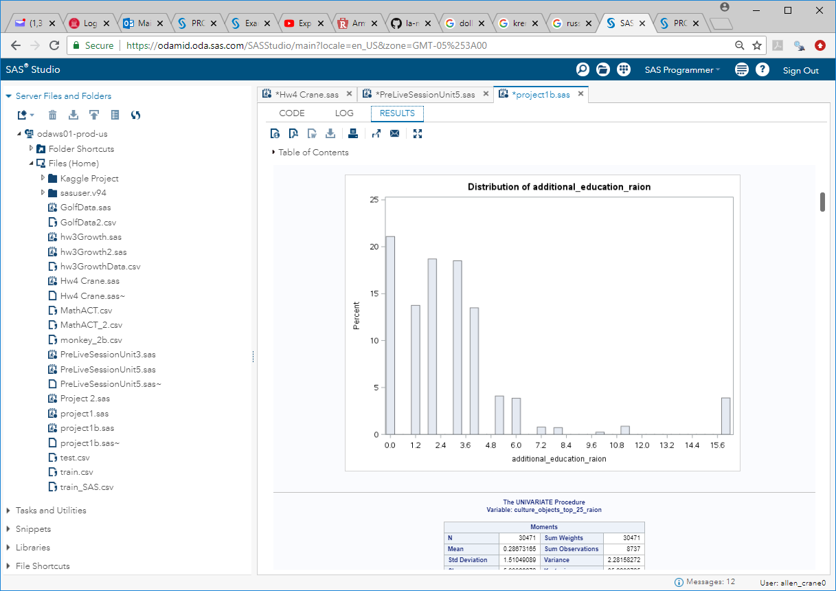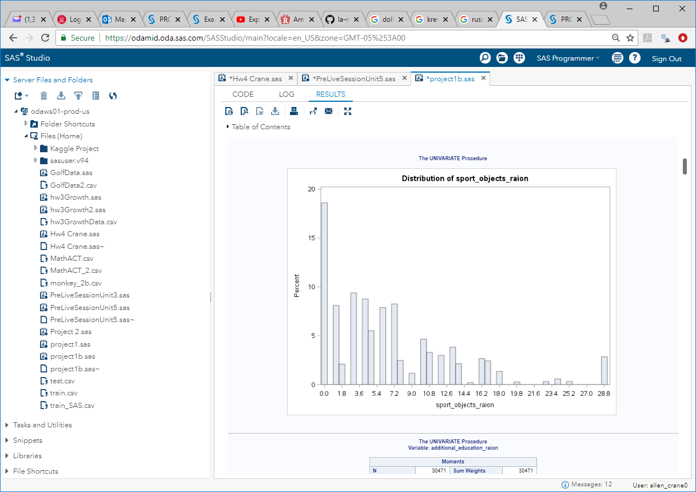

The same is true for many of the variables ending in “_raion” (“neighborhood, in Russian). Further investigation shows that these neighborhoods (a.k.a. “sub_area” in our data) correspond to affluent and government sections of greater Moscow, Presneskoe (Presnensky) and Tversekoe (Tverskoy). These data show that there are some sub_areas that are culturally and administratively dense enough to legitimize these data findings. Therefore, we will not omit these variables due to simply being outliers, else we may risk losing material information about their predictive power for property values in certain areas.

***Presnensky District*** *is an upscale area known for the State Museum of Oriental Art and quiet parks like Patriarch’s Ponds. Child-friendly attractions include the Moscow Zoo, and hands-on exhibits at the nearby Moscow Planetarium. A variety of restaurants serving European and fusion fare line Bolshaya Nikitskaya Street, which is also home to classic repertory at the Mayakovsky Theater.*

***Tverskoy District*** *is a district of Central Administrative Okrug of the federal city of Moscow, Russia. Population: 75,378; 75,955. The district extends from Kitai-gorod northwest to Belorussky and Savyolovsky Rail Terminals.*

*(source: Wikipedia)*

***Presnensk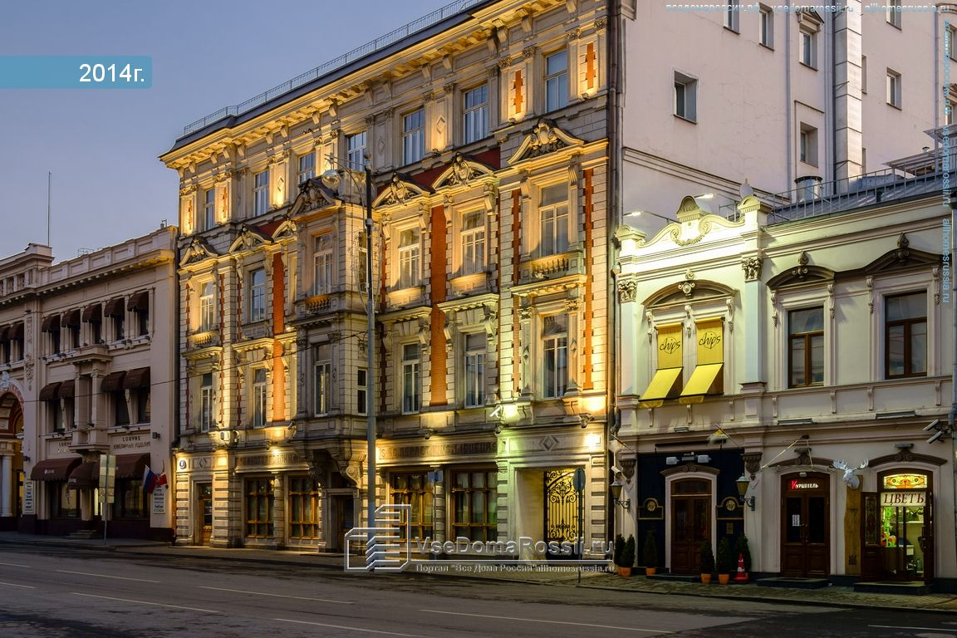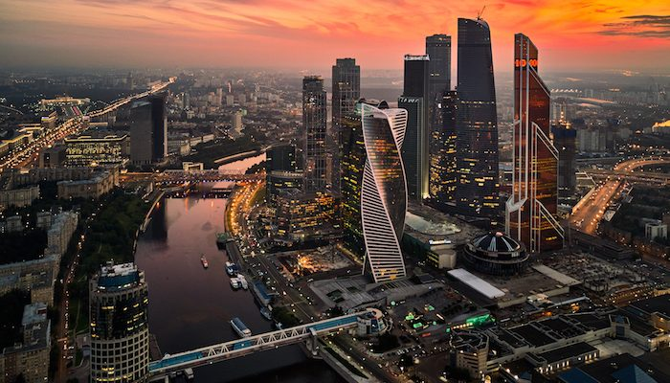y District Tverskoy District***

1. **Missing value identification, summary and possible imputation (mean, median, regression.) This may also be considered “Data Wrangling”.**

For our analysis, several numeric variables contained non-trivial percentages of missing data (percent of the data with “NA” listed as the value). Since the variable with the highest missing value rate (hospital_beds_raion) is 47%, throwing out the observations with missing values would limit us to just over half of the data set. Similarly, removing the entire variable(s) with missing values could cause us to miss significant coefficients for our predictive models. The following is a list of all variables in the TRAIN data set with missing values, and the missing value percentage of all observations for each variable)

**Variable Missing Value % (Percent“NA”) .**

hospital_beds_raion 47%

build_year 45%

state 44%

cafe_sum_500_min_price_avg 44%

cafe_sum_500_max_price_avg 44%

cafe_avg_price_500 44%

max_floor 31%

material 31%

num_room 31%

kitch_sq 31%

preschool_quota 22%

school_quota 22%

cafe_sum_1000_min_price_avg 21%

cafe_sum_1000_max_price_avg 21%

cafe_avg_price_1000 21%

life_sq 21%

raion_build_count_with_material_info 16%

build_count_block 16%

build_count_wood 16%

build_count_frame 16%

build_count_brick 16%

build_count_monolith 16%

build_count_panel 16%

build_count_foam 16%

build_count_slag 16%

build_count_mix 16%

raion_build_count_with_builddate_info 16%

build_count_before_1920 16%

build_count_1921-1945 16%

build_count_1946-1970 16%

build_count_1971-1995 16%

build_count_after_1995 16%

cafe_sum_2000_min_price_avg 6%

cafe_sum_2000_max_price_avg 6%

cafe_avg_price_2000 6%

cafe_sum_3000_min_price_avg 3%

cafe_sum_3000_max_price_avg 3%

cafe_avg_price_3000 3%

cafe_sum_5000_min_price_avg 1%

cafe_sum_5000_max_price_avg 1%

cafe_avg_price_5000 1%

prom_part_5000 1%

floor 1%

**Expectation maximization (EM) method for imputation of missing values**

According to Schlomer, Bauman, and Card, “This method is one of several maximum likelihood (ML) approaches. In all ML strategies, observed data are used to estimate parameters, which are then used to estimate the missing scores. These ML strategies have demonstrated superiority to deletion, nonstochastic imputation, and stochastic regression imputation methods (Roth, 1994) for multivariate normal distributions.The EM strategy is based on a recursive process: The missing data have information that is useful in estimating various parameters, and the estimated parameter has information that is useful in finding the most likely value of the missing data (Bennett, 2001). Thus, the EM method is an iterative procedure with two steps in each iteration: In the expectation step, the process is similar to the regression-based imputation. First, starting values for the parameters (e.g., means, covariances) are obtained with available data. Regression methods are used to impute, on the basis of these initial values, the values for the missing data. When this step is completed, in the maximization step new values for the parameters are calculated with the newly imputed data along with the original observed data. Then the process starts over with the expectation step and continues until the estimates change very little from one iteration to the next (i.e., until the estimates converge; Allison, 2001).” (*Source: Gabriel L. Schlomer, Sheri Bauman, and Noel A. Card, “Best Practices for Missing Data Management in Counseling Psychology”, Journal of Counseling Psychology 2010, Vol. 57, No. 1, 1–10)*

Below is the generic code for the PROC MI command: (see SAS code in Appendix for detail)

proc mi data=train2 seed=501213

mu0=0 out=train4;

var n_build_year

…

n_prom_part_5000;

run;

1. Multicollinearity (is there reason to believe it is present? You don’t have to address every potential pair of variables that may be collinear. Just provide a plot and or other evidence of a single occurrence of multicollinearity if at least one exists and then mention possible other occurrences.

In looking at the data, we can see several groups of variables that appear similar. Many of these are in the form of a distance or countable measure between the property (measured in increments of 500, 1000, 1500, 2000, 3000, and 5000 meters) and some item of significance (distance to a cafe with a certain min/max/average price, the number of large churches within an area, distance to leisure areas and markets, etc). An example of one series (“green_part_X”) is shown below:

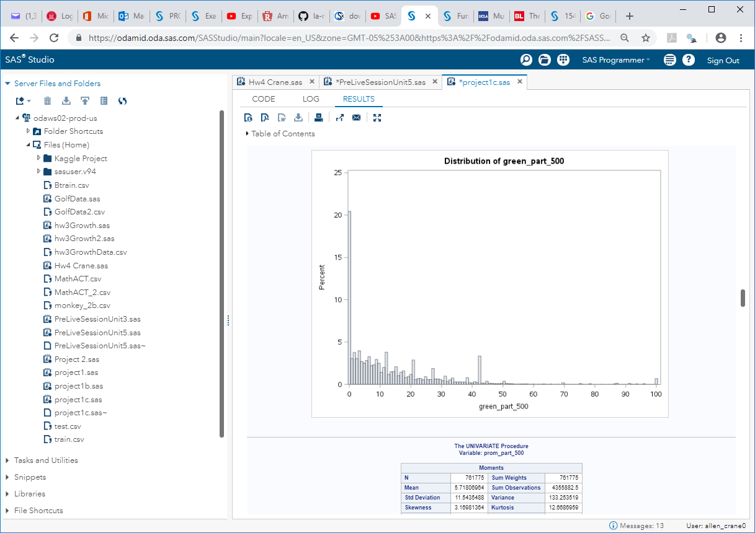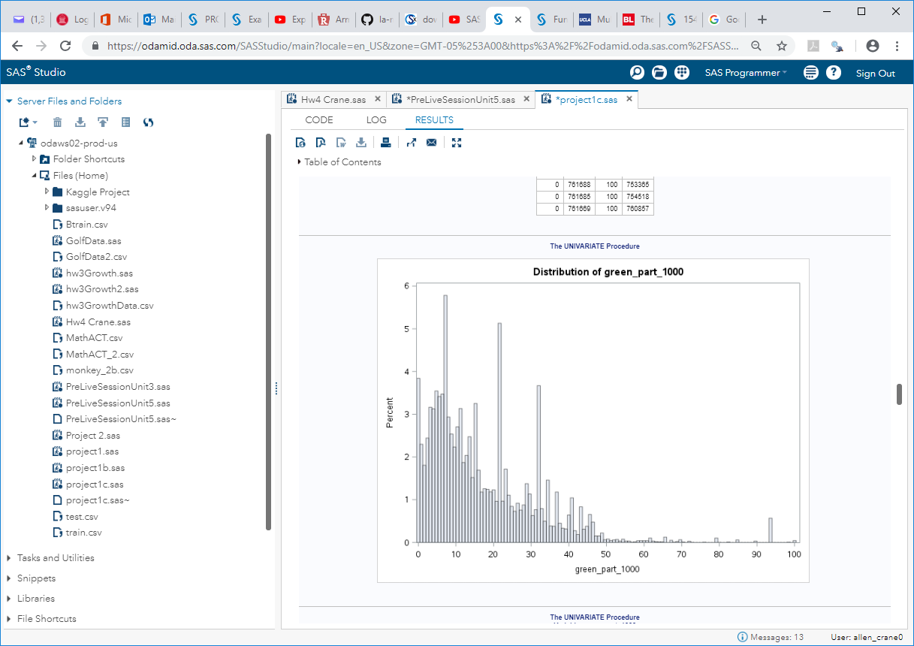

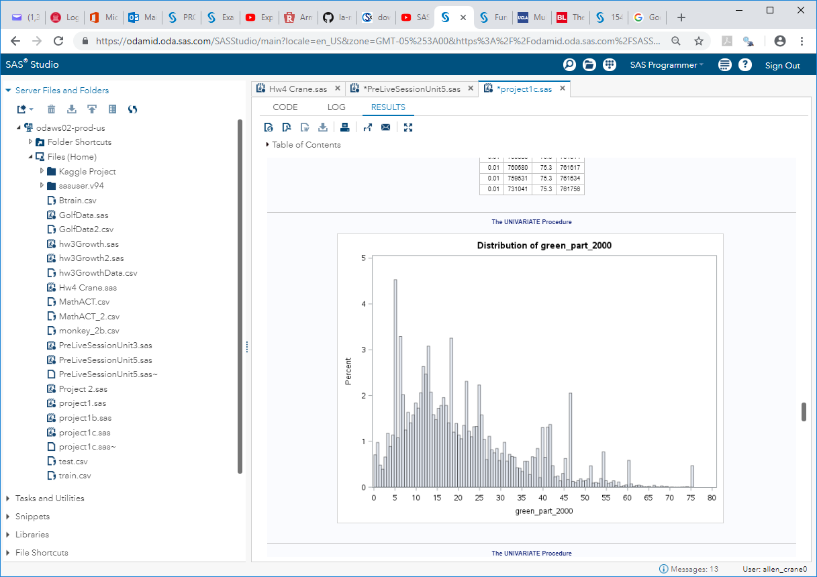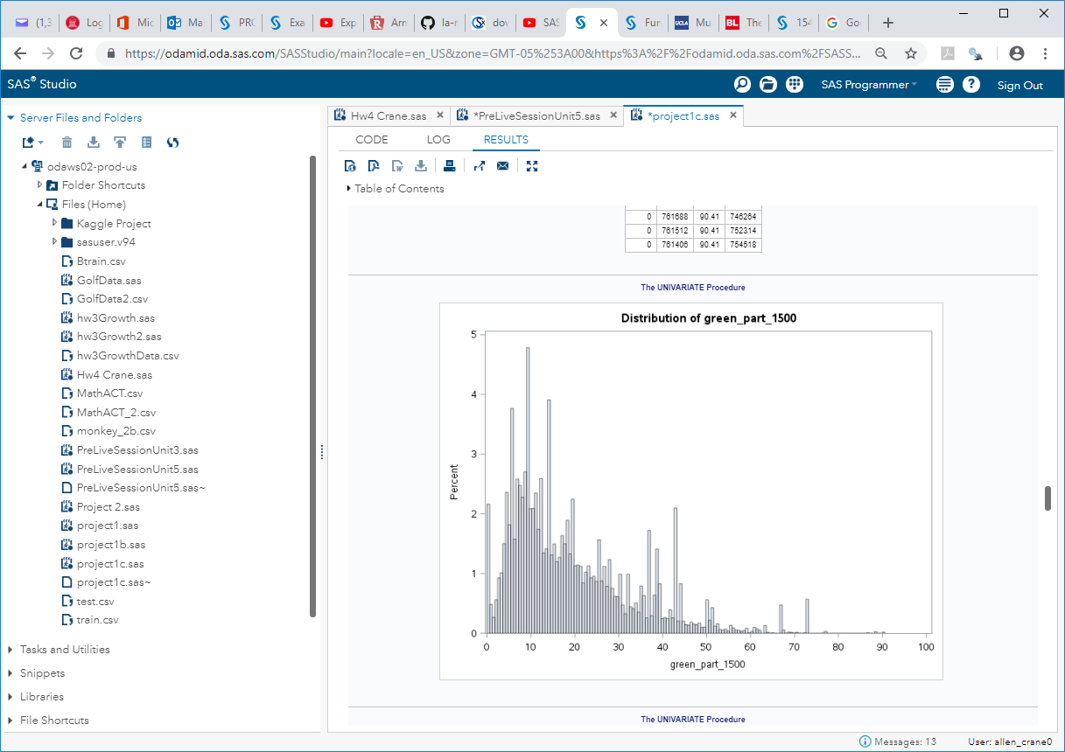

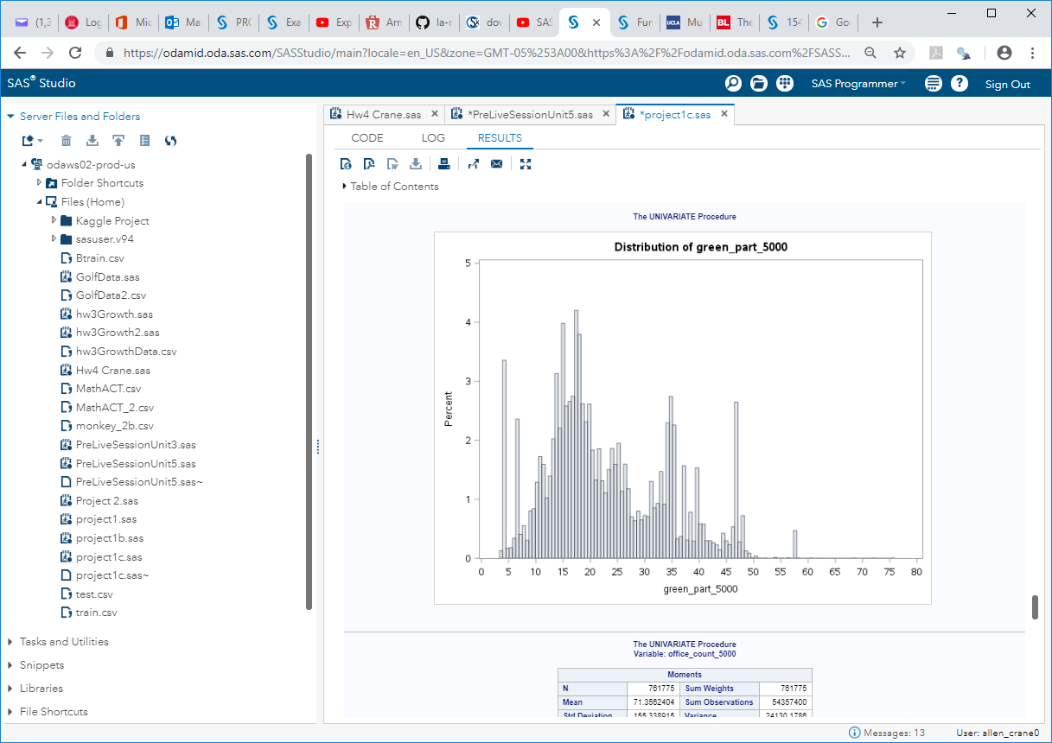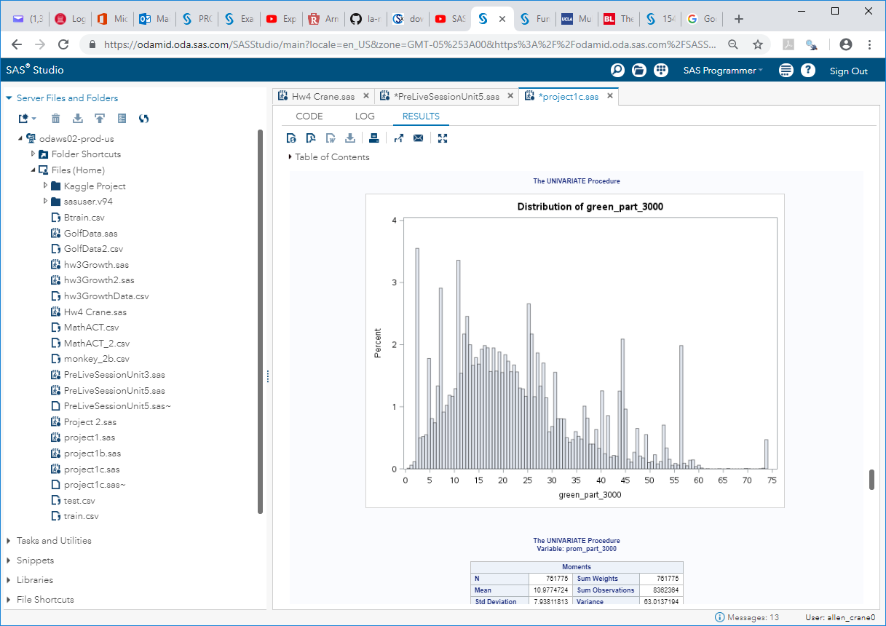

To address these, we experimented with several methods of variable reduction, including summing the variables in each group, choosing only one variable to represent each group, etc. While this seemed to improve the explanation of the model, we found that it actually reduced the R2 value, compared with loading all variables and letting the model test for significance (stepwise, forward, backward, stepwise AIC, stepwise SBC, stepwise AICC). In some cases, some of the grouped variables are dropped, while in other cases they are kept. We can speculate whether the kept variables are due to multicollinearity or if some of these distance differences are legitimate (for example, if distance to market is small, that may be more attractive to a prospective property owner, and hence values like cafes less than 1.5km are material, but those that are more than 5km are immaterial). As a result, we ran the model many different ways on variable selection and produced consistent R2 values around 0.64.

1. Checking assumptions: homoscedasticity, normal distributions of the response for fixed values of the explanatory variable(s), linear relationship between the mean of the response and each explanatory variable, etc. This is where you would apply transformation (log, square root, etc.)

For this analysis, we will use the White test for homoscedasticity, which is represented generically below. A value of > alpha = 0.05 indicates homoscedasticity, and therefore no transformation is needed. Alternatively, a value of < alpha = 0.05 indicates heteroscedasticity, which would indicate that some form of transformation is needed.

proc model data=data;

parms b0 b1;

y = b0 + b1* x;

fit y/white;

Run;

The following variables were determined to be heteroscedastic (value < alpha = 0.05):

1. High level variable selection would be included in the EDA. (Example: There are many potential explanatory variables. Running stepwise variable selection with a high entry and exit threshold will not provide a plausible final model, but may leave you with a smaller set of potential explanatory to work with.)

High level variable selection is included in the model detail.

1. Anything else that might be appropriate in learning about the data before getting started. (Example: You might try interactions between explanatory variables in the EDA.)

No interactions were tested.

**Modeling (fit at least 3 candidate models)**

1. A model with OLS parameter estimates. You may choose the variables with or without the use of a variable selection technique (forward, backward, stepwise) (You may have done this already in the EDA.)

**See Appendix 3: Model 1.1 OLS detail**

1. A model with LASSO estimation and selection.

**See Appendix 3: Model 1.2 LASSO detail**

1. A model of your choice. This may be using another OLS or LASSO model or custom model, etc.

**See Appendix 3: Model 1.2 LASSO detail**

*Notes:

In at least one of the models above, or in the EDA, you should test the significance of at least one term that involves an interaction.

You need to address the assumptions with respect to the residuals. (Normally distributed around 0 with constant standard deviation.)

For each model you need to conduct an internal and external cross validation.

You should compare the models using the AIC, SBC, Interval k-fold cross validation (you pick k), external cross validation. For external cross validation you will have to subset the train data set into modeling and test data sets.

**Prediction**

Identify which model you feel is the best and discuss why.

Use this model to predict the price of each of the 7662 properties in the prediction data set (*predictionData.csv*).

Submit these predictions in the zip file with your final paper. Please see the sample submission file. *SampleSubmission.csv*

*Note: It is understood that all the material above should supported with plots, tables, charts, discussions, etc. where appropriate. All plots and tables should be clearly labeled and referenced in the discussion and all tables referenced in the discussion should exist in the paper. It is never appropriate to have a plot or table in the paper that it not described / referenced in the writing. *Your team could lose points or gain points depending on how well your professor feels you described research / findings.*

**Goal 2: 3 Pages (*30 pts*)**

1. Introduction (Brief introduction to the problem … 2 to 3 sentences).
2. Data Wrangling: Here you will have to manipulate/wrangle the data to produce the data you will use in this analysis. Your goal is to get the mean price for each month/year combination. Hints:

Data Wrangling Use SAS, Python or R (hint: dplyr and tidyr packages) to separate the timestamp column into 3 columns. These three columns should be called “Day”, “Month” and “Year” respectively (any order is fine). To be clear, your task is to turn:

 into 

USE R,Python or SAS to aggregate the data by year and month. This means that the new dataset should have the mean of all the properties for a given month in a given year. You may do this using any method you like. The “aggregate” function in R is one way of doing this. As a reference, the first four months should match the values below.



1. Plot the time series of the price_doc versus the numbers 1 – 47 on the x-axis. You should simply name the x-axis “months”.
2. Model the residual series.
   1. Fit a simple linear regression model with price_doc as the response variable and Month_Number as the explanatory variable.
   2. Obtain the residuals from this model and plot them against the month number. Make sure this plot is a series rather than a scatter plot. This simply means make sure the points on the plot are connected by a line. Keep the x-axis label: “Month”.
   3. Fit the residual and time data using proc autoreg and investigate the autocorrelation structure based on the Durbin-Watson statistic, partial autocorrelation plots, AIC and SBC. You studied the AR(1) model in depth in Unit 4, it is possible you may find that an AR(p) with p > 1 is a better fit to this data. Explore what this means in terms of intuition, model construction and forecasting.
   4. Use your model from part c to forecast the residual for the next year (June 2015 – June 2016) with 95% confidence intervals.
3. Using your model from the last question and the series of residuals, forecast the next year: July 2015 – June 2016 and of course include 95% confidence intervals. You can do this by obtaining an estimate from the model in part b for the mean price and then add to it the forecast residuals from the model in part e. The confidence interval won’t be exact but a very conservative estimate will be to add the upper and lower bound from each model.
4. Submit your forecasts (with confidence intervals) as well as your final csv data set you used in the analysis (wrapped in a zip file.)

**Appendix 1: Data Dictionary *3 pts***

The initial TRAIN data set contains property references references

**Feature**  **Description .**

id Property ID

timestamp Date of property entry

area_m Area mun. area, sq.m.

raion_popul Number of municipality population. District

green_zone_part Proportion of area of greenery in the total area

indust_part Share of industrial zones in area of the total area

children_preschool Number of pre-school age population

preschool_quota Number of seats in pre-school organizations

preschool_education_centers_raion Number of pre-school institutions

children_school Population of school-age children

school_quota Number of high school seats in area

school_education_centers_raion Number of high school institutions

school_education_centers_top_20_raion Number of high schools of the top 20 best schools in Moscow

hospital_beds_raion Number of hospital beds for the district

healthcare_centers_raion Number of healthcare centers in district

university_top_20_raion Number of higher education institutions in the top ten ranking of the Federal rank sport_objects_raion Number of higher education institutions

additional_education_raion Number of additional education organizations

culture_objects_top_25 Presence of the key objects of cultural heritage

culture_objects_top_25_raion Number of objects of cultural heritage

shopping_centers_raion Number of malls and shopping centres in district

thermal_power_plant_raion Presence of thermal power station in district

incineration_raion Presence of incinerators

oil_chemistry_raion Presence of dirty industries

radiation_raion Presence of radioactive waste disposal

railroad_terminal_raion Presence of the railroad terminal in district

big_market_raion Presence of large grocery / wholesale markets

nuclear_reactor_raion Presence of existing nuclear reactors

detention_facility_raion Presence of detention centers, prisons

full_all Total number of population in the municipality

male_f Male population

female_f Female population

young_all Population younger than working age

young_male Male population younger than working age

young_female Female population younger than working age

work_all Working population

build_count_monolith Share of monolith buildings

build_count_panel Share of panel buildings

build_count_foam Share of foam buildings

build_count_slag Share of slag buildings

build_count_mix Share of mixed buildings

raion_build_count_with_builddate_info Number of building with build year info in district

build_count_before_1920 Share of before_1920 buildings

build_count_1921-1945 Share of 1921-1945 buildings

build_count_1946-1970 Share of 1946-1970 buildings

build_count_1971-1995 Share of 1971-1995 buildings

build_count_after_1995 Share of after_1995 buildings

7_14_male Male population aged 7-14

7_14_female Female population aged 7-14

0_17_all Population aged 0-17

0_17_male Male population aged 0-17

0_17_female Female population aged 0-17

16_29_all Population aged 16-19

16_29_male Male population aged 16-19

16_29_female Female population aged 16-19

0_13_all Population aged 0-13

0_13_male Male population aged 0-13

0_13_female Female population aged 0-13

metro_min_avto Time to subway by car, min.

metro_km_avto Distance to subway by car, km

metro_min_walk Time to metro by foot

metro_km_walk Distance to the metro, km

kindergarten_km Distance to kindergarten

school_km Distance to high school

park_km Distance to park

green_zone_km Distance to green zone

industrial_zone_km Distance to industrial zone

water_treatment_km Distance to water treatment

cemetery_km Distance to the cemetery

incineration_km Distance to the incineration

railroad_station_walk_km Distance to the railroad station (walk)

railroad_station_walk_min Time to the railroad station (walk)

ID_railroad_station_walk Nearest railroad station id (walk)

railroad_station_avto_km Distance to the railroad station (avto)

railroad_station_avto_min Time to the railroad station (avto)

ID_railroad_station_avto Nearest railroad station id (avto)

public_transport_station_km Distance to the public transport station (walk)

public_transport_station_min_walk Time to the public transport station (walk)

water_km Distance to the water reservoir / river

water_1line First line to the river (150 m)

mkad_km Distance to MKAD (Moscow Circle Auto Road)

ttk_km Distance to the TTC (Third Transport Ring)

sadovoe_km Distance to the Garden Ring

bulvar_ring_km The distance to the Boulevard Ring

kremlin_km Distance to the city center (Kremlin)

big_road1_km Distance to Nearest major road

ID_big_road1 Nearest big road id

big_road1_1line First line to the road (100 m for highwys, 250 m to MKAD)

big_road2_km The distance to next distant major road

ID_big_road2 2nd nearest big road id

railroad_km Distance to the railway / Moscow Central Ring / open areas Underground railroad_1line First line to the railway (100 m)

zd_vokzaly_avto_km Distance to train station

ID_railroad_terminal Nearest railroad terminal id

bus_terminal_avto_km Distance to bus terminal (avto)

ID_bus_terminal Nearest bus terminal id

oil_chemistry_km Distance to dirty industries

nuclear_reactor_km Distance to nuclear reactor

radiation_km Distance to burial of radioactive waste

power_transmission_line_km Distance to power transmission line

thermal_power_plant_km Distance to thermal power plant

ts_km Distance to power station

big_market_km Distance big market

fitness_km Distance to fitness

swim_pool_km Distance to swimming pool

ice_rink_km Distance to ice palace

stadium_km Distance to stadium

basketball_km Distance to the basketball courts

hospice_morgue_km Distance to hospice/morgue

detention_facility_km Distance to detention facility

public_healthcare_km Distance to public healthcare

university_km Distance to universities

workplaces_km Distance to workplaces

shopping_centers_km Distance to shopping centers

o‑ce_km Distance to business centers/ o‑ces

additional_education_km Distance to additional education

preschool_km Distance to preschool education organizations

big_church_km Distance to large church

church_synagogue_km Distance to Christian churches and Synagogues

mosque_km Distance to mosques

theater_km Distance to theater

museum_km Distance to museums

exhibition_km Distance to exhibition

catering_km Distance to catering

ecology Ecological zone where the house is located

green_part_500 The share of green zones in 500 meters zone

prom_part_500 The share of industrial zones in 500 meters zone

o‑ce_count_500 The number of o‑ce space in 500 meters zone

o‑ce_sqm_500 The square of o‑ce space in 500 meters zone

trc_count_500 The number of shopping malls in 500 meters zone

trc_sqm_500 The square of shopping malls in 500 meters zone

cafe_count_500 The number of cafes or restaurants in 500 meters zone cafe_sum_500_min_price_avg Cafes and restaurant min average bill in 500 meters zone cafe_sum_500_max_price_avg Cafes and restaurant max average bill in 500 meters zone

cafe_avg_price_500 Cafes and restaurant average bill in 500 meters zone

cafe_count_500_na_price Cafes and restaurant bill N/A in 500 meters zone

cafe_count_500_price_500 Cafes and restaurant bill, average under 500 in 500 meters zone

cafe_count_500_price_1000 Cafes and restaurant bill, average 500-1000 in 500 meters zone cafe_count_500_price_1500 Cafes and restaurant bill, average 1000-1500 in 500 meters zone cafe_count_500_price_2500 Cafes and restaurant bill, average 1500-2500 in 500 meters zone cafe_count_500_price_4000 Cafes and restaurant bill, average 2500-4000 in 500 meters zone cafe_count_500_price_high Cafes and restaurant bill, average over 4000 in 500 meters zone big_church_count_500 The number of big churches in 500 meters zone

church_count_500 The number of churches in 500 meters zone

mosque_count_500 The number of mosques in 500 meters zone

leisure_count_500 The number of leisure facilities in 500 meters zone

sport_count_500 The number of sport facilities in 500 meters zone

market_count_500 The number of markets in 500 meters zone

green_part_1000 The share of green zones in 1000 meters zone

prom_part_1000 The share of industrial zones in 1000 meters zone

o‑ce_count_1000 The number of o‑ce space in 1000 meters zone

o‑ce_sqm_1000 The square of o‑ce space in 1000 meters zone

trc_count_1000 The number of shopping malls in 1000 meters zone

trc_sqm_1000 The square of shopping malls in 1000 meters zone

cafe_count_1000 The number of cafes or restaurants in 1000 meters zone cafe_sum_1000_min_price_avg Cafes and restaurant min average bill in 1000 meters zone cafe_sum_1000_max_price_avg Cafes and restaurant max average bill in 1000 meters zone

cafe_avg_price_1000 Cafes and restaurant average bill in 1000 meters zone

cafe_count_1000_na_price Cafes and restaurant bill N/A in 1000 meters zone

cafe_count_1000_price_500 Cafes and restaurant bill, average under 500 in 1000 meters zone cafe_count_1000_price_1000 Cafes and restaurant bill, average 500-1000 in 1000 meters zone cafe_count_1000_price_1500 Cafes and restaurant bill, average 1000-1500 in 1000 meters zone cafe_count_1000_price_2500 Cafes and restaurant bill, average 1500-2500 in 1000 meters zone cafe_count_1000_price_4000 Cafes and restaurant bill, average 2500-4000 in 1000 meters zone cafe_count_1000_price_high Cafes and restaurant bill, average over 4000 in 1000 meters zone big_church_count_1000 The number of big churchs in 1000 meters zone

church_count_1000 The number of churches in 1000 meters zone

mosque_count_1000 The number of mosques in 1000 meters zone

leisure_count_1000 The number of leisure facilities in 1000 meters zone

sport_count_1000 The number of sport facilities in 1000 meters zone

market_count_1000 The number of markets in 1000 meters zone

green_part_1500 The share of green zones in 1500 meters zone

prom_part_1500 The share of industrial zones in 1500 meters zone

o‑ce_count_1500 The number of o‑ce space in 1500 meters zone

o‑ce_sqm_1500 The square of o‑ce space in 1500 meters zone

trc_count_1500 The number of shopping malls in 1500 meters zone

trc_sqm_1500 The square of shopping malls in 1500 meters zone

cafe_count_1500 The number of cafes or restaurants in 1500 meters zone cafe_sum_1500_min_price_avg Cafes and restaurant min average bill in 1500 meters zone cafe_sum_1500_max_price_avg Cafes and restaurant max average bill in 1500 meters zone

cafe_avg_price_1500 Cafes and restaurant average bill in 1500 meters zone

cafe_count_1500_na_price Cafes and restaurant bill N/A in 1500 meters zone

cafe_count_1500_price_500 Cafes and restaurant bill, average under 500 in 1500 meters zone cafe_count_1500_price_1000 Cafes and restaurant bill, average 500-1000 in 1500 meters zone cafe_count_1500_price_1500 Cafes and restaurant bill, average 1000-1500 in 1500 meters zone cafe_count_1500_price_2500 Cafes and restaurant bill, average 1500-2500 in 1500 meters zone cafe_count_1500_price_4000 Cafes and restaurant bill, average 2500-4000 in 1500 meters zone cafe_count_1500_price_high Cafes and restaurant bill, average over 4000 in 1500 meters zone big_church_count_1500 The number of big churches in 1500 meters zone

church_count_1500 The number of churches in 1500 meters zone

mosque_count_1500 The number of mosques in 1500 meters zone

leisure_count_1500 The number of leisure facilities in 1500 meters zone

sport_count_1500 The number of sport facilities in 1500 meters zone

market_count_1500 The number of markets in 1500 meters zone

green_part_2000 The share of green zones in 2000 meters zone

prom_part_2000 The share of industrial zones in 2000 meters zone

o‑ce_count_2000 The number of o‑ce space in 2000 meters zone

o‑ce_sqm_2000 The square of o‑ce space in 2000 meters zone

trc_count_2000 The number of shopping malls in 2000 meters zone

trc_sqm_2000 The square of shopping malls in 2000 meters zone

cafe_count_2000 The number of cafes or restaurants in 1500 meters zone cafe_sum_2000_min_price_avg Cafes and restaurant min average bill in 2000 meters zone cafe_sum_2000_max_price_avg Cafes and restaurant max average bill in 2000 meters zone

cafe_avg_price_2000 Cafes and restaurant average bill in 2000 meters zone

cafe_count_2000_na_price Cafes and restaurant bill N/A in 2000 meters zone

cafe_count_2000_price_500 Cafes and restaurant bill, average under 500 in 2000 meters zone cafe_count_2000_price_1000 Cafes and restaurant bill, average 500-1000 in 2000 meters zone cafe_count_2000_price_1500 Cafes and restaurant bill, average 1000-1500 in 2000 meters zone cafe_count_2000_price_2500 Cafes and restaurant bill, average 1500-2500 in 2000 meters zone cafe_count_2000_price_4000 Cafes and restaurant bill, average 2500-4000 in 2000 meters zone cafe_count_2000_price_high Cafes and restaurant bill, average over 4000 in 2000 meters zone big_church_count_2000 The number of big churchs in 2000 meters zone

church_count_2000 The number of churchs in 2000 meters zone

mosque_count_2000 The number of mosques in 2000 meters zone

leisure_count_2000 The number of leisure facilities in 2000 meters zone

sport_count_2000 The number of sport facilities in 2000 meters zone

market_count_2000 The number of markets in 2000 meters zone

green_part_3000 The share of green zones in 3000 meters zone

prom_part_3000 The share of industrial zones in 3000 meters zone

o‑ce_count_3000 The number of o‑ce space in 3000 meters zone

o‑ce_sqm_3000 The square of o‑ce space in 3000 meters zone

trc_count_3000 The number of shopping malls in 3000 meters zone

trc_sqm_3000 The square of shopping malls in 3000 meters zone

cafe_count_3000 The number of cafes or restaurants in 1500 meters zone cafe_sum_3000_min_price_avg Cafes and restaurant min average bill in 3000 meters zone cafe_sum_3000_max_price_avg Cafes and restaurant max average bill in 3000 meters zone

cafe_avg_price_3000 Cafes and restaurant average bill in 3000 meters zone

cafe_count_3000_na_price Cafes and restaurant bill N/A in 3000 meters zone

cafe_count_3000_price_500 Cafes and restaurant bill, average under 500 in 3000 meters zone cafe_count_3000_price_1000 Cafes and restaurant bill, average 500-1000 in 3000 meters zone cafe_count_3000_price_1500 Cafes and restaurant bill, average 1000-1500 in 3000 meters zone cafe_count_3000_price_2500 Cafes and restaurant bill, average 1500-2500 in 3000 meters zone cafe_count_3000_price_4000 Cafes and restaurant bill, average 2500-4000 in 3000 meters zone cafe_count_3000_price_high Cafes and restaurant bill, average over 4000 in 3000 meters zone big_church_count_3000 The number of big churches in 3000 meters zone

church_count_3000 The number of churches in 3000 meters zone

mosque_count_3000 The number of mosques in 3000 meters zone

leisure_count_3000 The number of leisure facilities in 3000 meters zone

sport_count_3000 The number of sport facilities in 3000 meters zone

market_count_3000 The number of markets in 3000 meters zone

green_part_5000 The share of green zones in 5000 meters zone

prom_part_5000 The share of industrial zones in 5000 meters zone

o‑ce_count_5000 The number of o‑ce space in 5000 meters zone

o‑ce_sqm_5000 The square of o‑ce space in 5000 meters zone

trc_count_5000 The number of shopping malls in 5000 meters zone

trc_sqm_5000 The square of shopping malls in 5000 meters zone

cafe_count_5000 The number of cafes or restaurants in 1500 meters zone cafe_sum_5000_min_price_avg Cafes and restaurant min average bill in 5000 meters zone cafe_sum_5000_max_price_avg Cafes and restaurant max average bill in 5000 meters zone

cafe_avg_price_5000 Cafes and restaurant average bill in 5000 meters zone

cafe_count_5000_na_price Cafes and restaurant bill N/A in 5000 meters zone

cafe_count_5000_price_500 Cafes and restaurant bill, average under 500 in 5000 meters zone cafe_count_5000_price_1000 Cafes and restaurant bill, average 500-1000 in 5000 meters zone cafe_count_5000_price_1500 Cafes and restaurant bill, average 1000-1500 in 5000 meters zone cafe_count_5000_price_2500 Cafes and restaurant bill, average 1500-2500 in 5000 meters zone cafe_count_5000_price_4000 Cafes and restaurant bill, average 2500-4000 in 5000 meters zone cafe_count_5000_price_high Cafes and restaurant bill, average over 4000 in 5000 meters zone big_church_count_5000 The number of big churches in 5000 meters zone

church_count_5000 The number of churches in 5000 meters zone

mosque_count_5000 The number of mosques in 5000 meters zone

leisure_count_5000 The number of leisure facilities in 5000 meters zone

sport_count_5000 The number of sport facilities in 5000 meters zone

market_count_5000 The number of markets in 5000 meters zone

price_doc Sale price of the property (presumably in Rubles)

**Appendix 2: Code *7pts***

(Well commented … Remember: Reproducible Research!)

1. This Appendix does not count against your page count.
2. Simply cut and paste your well commented code here.

**Submissions:**

What to submit 2 DS in a single zip file:

1. Prediction from Goal 1. (csv file)
2. Wrangled data set from Goal 2. (48 rows including title row. / csv file)
3. Predictions from Goal 2. (csv file)
4. Line plot of predictions from Goal 2 with 95% confidence intervals. Image or cut and pasted into something like a word doc.
5. Final paper (No longer than 11 pages without appendix.) LaTex/Word/ etc.

**Note: Data Wrangling:**

*Wrangling = having a long and complicated dispute.*

Part of this project is meant to have a significant data wrangling component. As an example, you will more than likely need to work with R or SAS or both to change data from character/string to integer/numeric so your models make the predictions that are required. This is only an example of the data wrangling you will need to conduct. It will help to start early and bring these issues up in live session and/or office hours.

**Appendix 3. Models**

**Model 1.1 OLS (Adj R2 = 0.6268)**

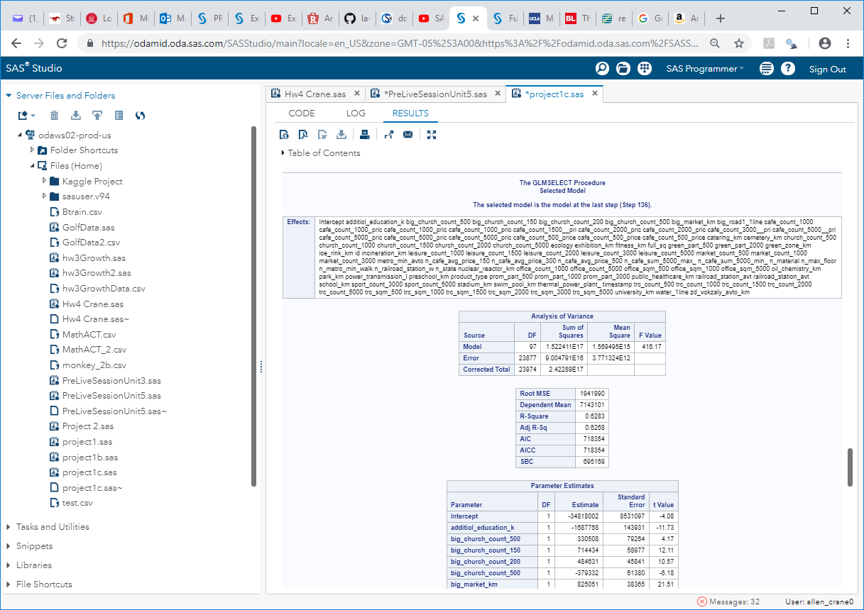

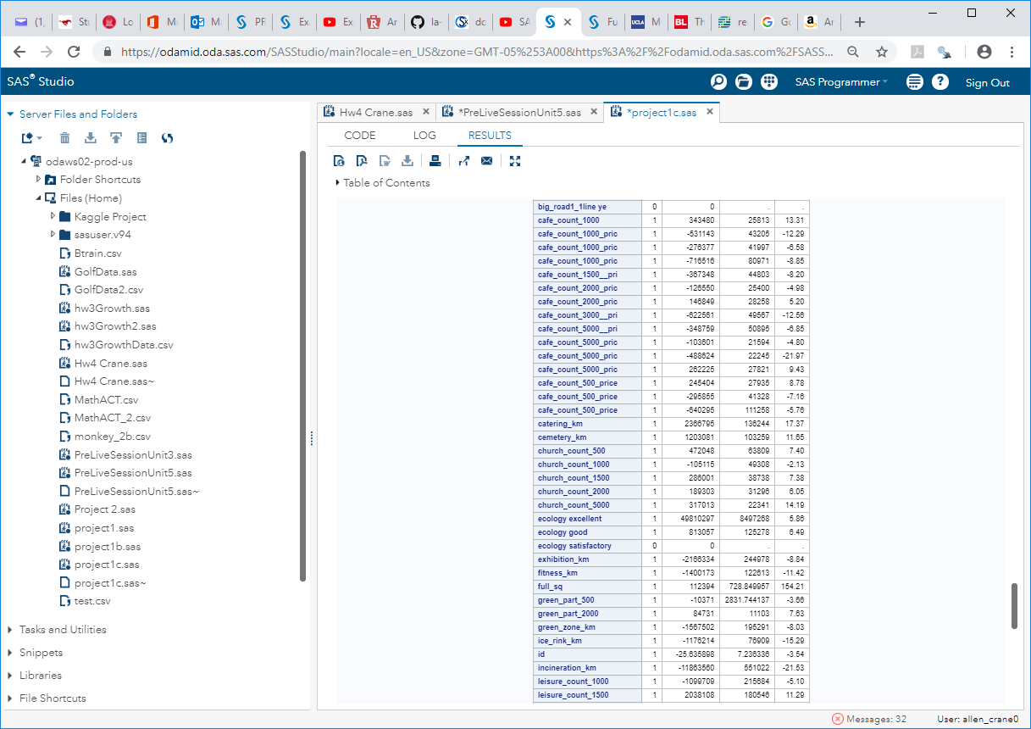

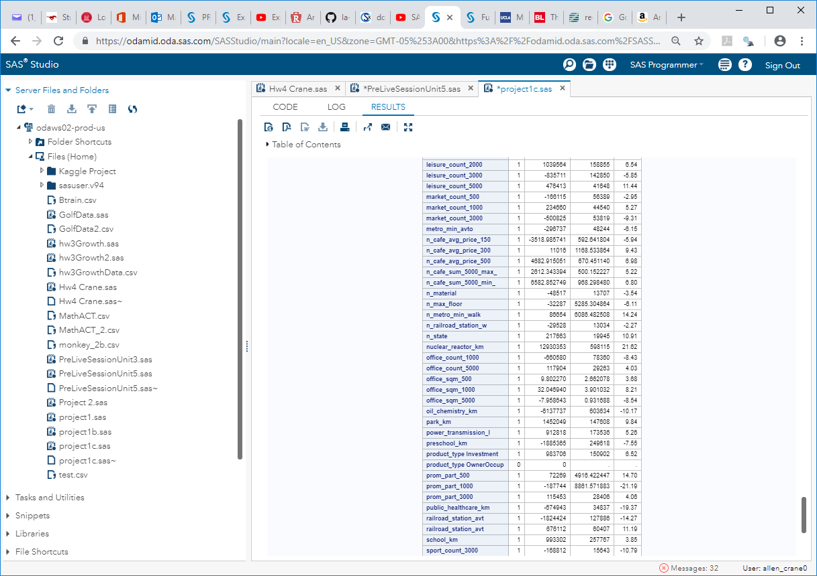

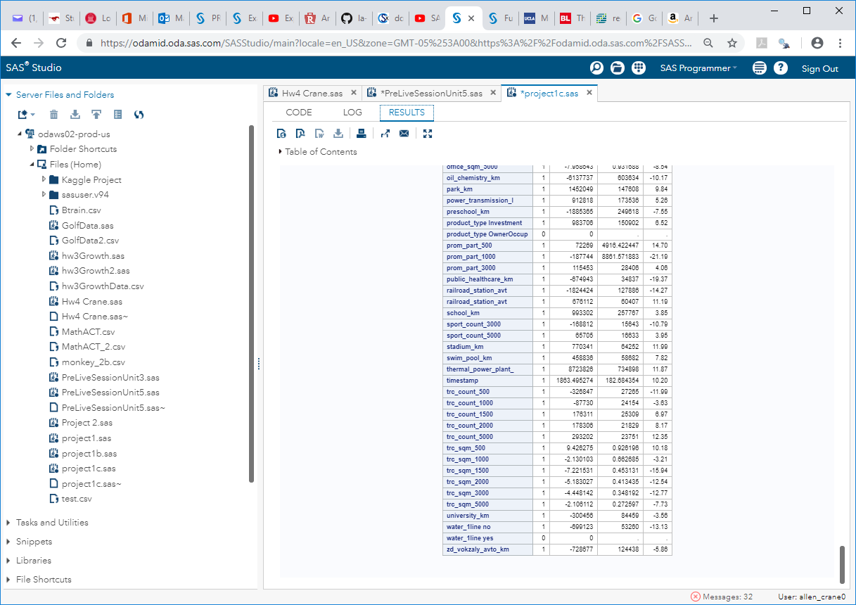

**Model 1.2 LASSO (Adj R2 = 0.5368)**

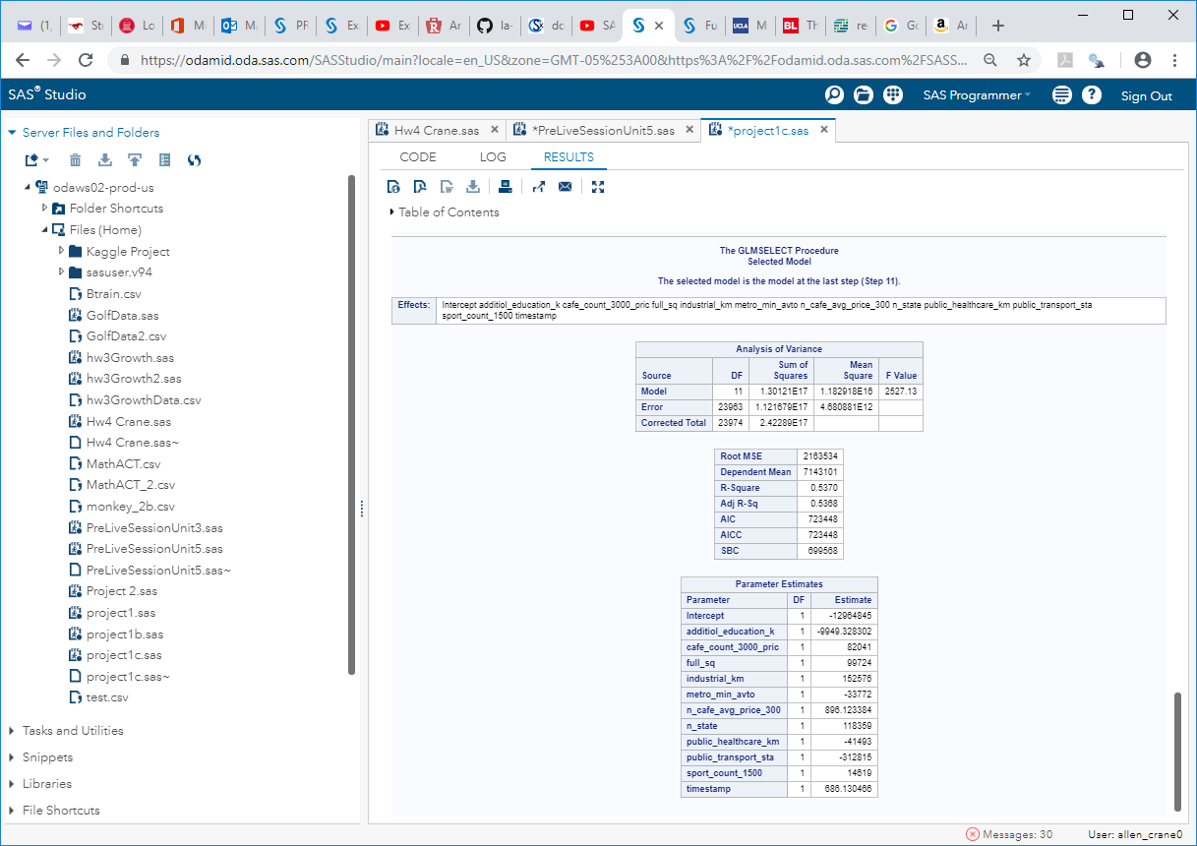

**Model 1.3 LARS (Adj R2 = 0.5368)**

